|  |  |
| --- | --- |
|  |  |

I'm making a write-up explanation. The completed section is at the end; please proof it for grammar and accuracy.   Immediately below is stuff we talked about yesterday that I'm not clear about.

   If you look at a small block toward the center of the schematic with multiple vertical lines (to the left of the MCM box) called ECM you'll notice the top of these lines have white arrows on top of the dots.  The arrow means the signal is coming or going from that specific wire from the location designated on top of the arrow.  An example is the first wire D2 which has a blue and a red dot; it is coming to the ECM from A16 BCM

My question: I'm confused by the two dots representing MCM and ECM yet only one A16 designation.  Is it coming from two locations?  It's coming from A16 in the MCM to D2 on the ECM... why two colored dots?

The two dots here - one being blue (or yellow if inverted) - indicate that this signal interfaces with the ECM, then heads to the MCM or BCM. This second dot was necessary since I already had a single dot indicating signals heading to either the MCM (GRN=left, RED=right) or BCM (BLU=to battery, PRP=to somewhere else).

A way to think about the dot system is that I devised this schematic while reverse engineering the IMA system… as such, I didn’t initially care what a signal ‘was’, per se, but rather I just cared where it went. An example thought process is “ok, the IMA battery fan control goes to the BCM.” At the end of the day, all I cared about was which signals went to which computer, since my goal was (successfully) to only replace the MCM (leaving the BCM connector unplugged).

So that’s why I’m using various colored circles… if I’m at some sensor/connector/etc, I can quickly determine which computer it goes to (BCM/MCM/ECM). So for example, looking at the pin ‘D2’ that you describe: without looking anywhere else, I immediately know this signal comes from the ECM (BLU dot, and arrow direction), and that it connects to the MCM (and more specifically, that it’s on the left MCM block). While I can certainly go to the MCM and verify this signal, that’s not typically important, unless I’m looking for the connector pin number at the MCM… but otherwise I don’t need to do this… simply by looking at the colored circles I know all I need to know.

Also I sent a couple of questions about the search function of the searchable maintenance databases.. Please answer these too.

I believe I already answered this… the schematic would need to be entirely redrawn in vector format… I never did that because I know the schematic like the back of my hand. The reason it’s just an image is that this schematic is literally copy-pasted from the Honda Service Manual… and then I manipulated the hell out of it to make it easier to understand (for me, at least).

EXPLANATION of IMA SCHEMATIC

This is an effort to explain the IMA schematic that Mudder put into the community. It's somewhat complicated if you need more specifics other than a wire color going to a module.

You can access the schematic here:

https://github.com/doppelhub/G1\_Honda\_Insight\_IMA/blob/master/OEM%20G1%20Honda%20Insight%20IMA%20Wiring/Complete%20IMA%20schematic.png

This schematic includes EVERY SINGLE WIRE that physically exists in – or orginates from - the IMA bay. If a wire doesn’t exist in this schematic, then it IS NOT in the IMA bay. Period.

General note: This schematic is a large image. It is not searchable.

General note: This schematic was not developed with the intent to distribute it. It is uniquely tailored to Mudder’s personal liking, which is largely based on his decades of reading and creating schematics. The insight community has shown an interest in the IMA schematic, and Mudder often references it on this forum. Therefore, this schematic is being provided to the community AS-IS, in the hopes that it’s useful. No warranty is expressed or implied, particularly regarding accuracy. However, note that Mudder has used this schematic as the basis for his extensive IMA tinkering, and has even created a replacement computer based on the information contained within.

The GENERAL subsystem layout is highlighted in the image below:

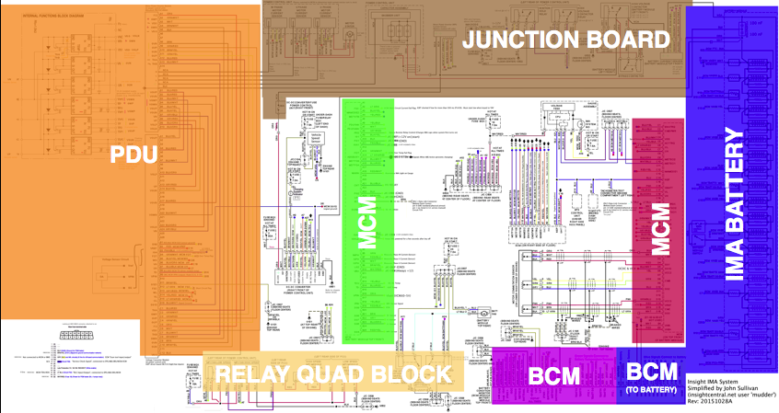The full size version is available here:

[https://github.com/doppelhub/G1\_Honda\_Insight\_IMA/blob/master/OEM%20G1%20Honda%20Insight%20IMA%20Wiring/Complete%20IMA%20schematic-GENERAL\_OVERVIEW.png](https://github.com/doppelhub/G1_Honda_Insight_IMA/blob/master/OEM G1 Honda Insight IMA Wiring/Complete IMA schematic-GENERAL_OVERVIEW.png)Unhighlighted areas have text location descriptions.

There are colored dots above most wires that connect to the MCM, BCM, or ECM. This is to reduce the spaghetti schematic… there are TONS of wires in the IMA bay, and they go pretty much everywhere. Dots are used to represents a wire going from (or to) one of the computers:

Purple = BCM wires that DO NOT connect to the battery

Blue= BCM wires that connect to the battery

Green= MCM (left schematic block; the MCM has a TON of wires, so it’s broken into two block).

Red = MCM (right schematic block)

Blue =  ECM. Note: All ECM wires either connect to the BCM or MCM… as such, there’s a second dot on all ECM lines indicating which computer (BCM or MCM) the wire goes to. There’s also a black arrow that indicates the signal’s direction of travel for all ECM lines.

Black dots are random on a case-by-case basis.

Knowing the information above, it becomes trivial to determine which computer any IMA wire connects to.

If a particular signal has only one colored dot, that means there is EXACTLY one other place where that wire goes; using the above colors, you can rapidly determine where said other half resides. For example, the top-right-most colored dot on the entire schematic is purple and labelled “A3”, with signal name “IPWR+”:

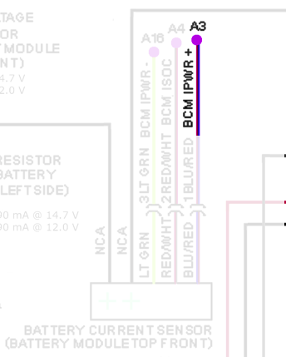

Since there’s just one colored circle, we know this signal only goes to EXACTLY ONE other location. Since the dot is purple, we know this is the BCM.

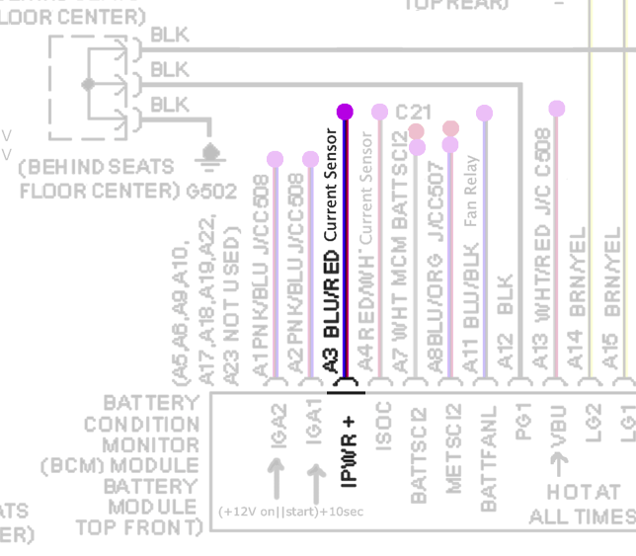

If a line has multiple dots, that means it goes to multiple locations, except for the ECM lines (which always have a blue dot in ADDITION to the MCM/BCM dot). If the dots are different colors that means the wire goes to multiple modules. If it has multiple dots of the same color that means it goes to that color's module multiple times.

If you look at a small block near the center of the schematic with 10+ vertical lines (to the left of the MCM box) called ECM. Example 2.   The top of these lines have white arrows on top of the dots.  An arrow means the signal is coming to or going from that specific wire. An example is the first wire D2 which has a blue and a red dot; it is coming from A16 at the MCM to D2 at the ECM.

At the far left of the schematic there's a box called Internal Functions Block Diagram. Example 3   That block is a breakout of the box directly to the right, the Motor Power Inverter module (MPI). The designations on the MPI correspond to the Internal Functions Block Diagram connections. Examples are the MPI A1 connection labeled FO and MPI B1 labeled VGVP are both on the Internal Functions Block Diagram.  Where you see a question mark, anywhere on this schematic, there is a question as to the accuracy of the specific designation.  An example is on the Internal Functions Block Diagram, third designation from the top, VNC, it's either the same as VGG or VGLN.  There is a schematic correction of the Internal Functions Block Diagram at the temperature sensor (to the left of the internal square labeled TEMP).  A line going to the top ground is X'ed out which means it is not connected (it never did), and instead the lines from the temperature sensor goes to TH (THA and THB).

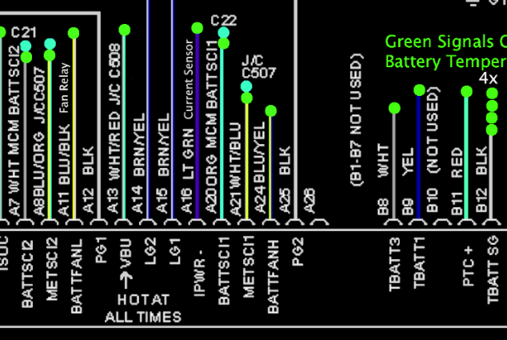

Example 1

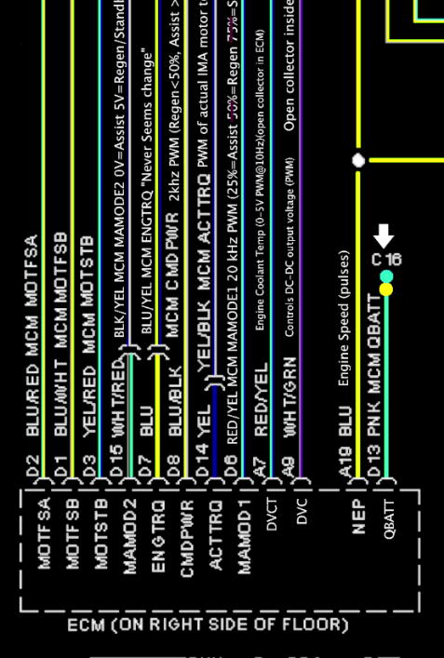 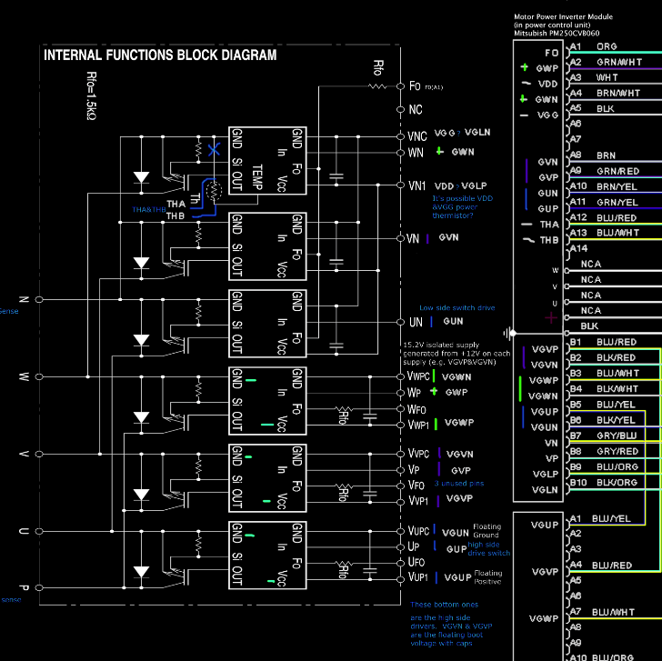

Example 2 Example 3